LAB-2

Anushka chauhan
SC-1
Roll no = 11
Date= 21/1/26
DBMS LAB

CREATE TABLE College (
name VARCHAR(10),
state VARCHAR(10),
enrollment INT
);
CREATE TABLE Student (
sID VARCHAR(10),
GPA NUMERIC(2,1)
);
CREATE TABLE Apply (
cName VARCHAR(20),
major VARCHAR(20),
sID VARCHAR(10),
decision CHAR(1)
);
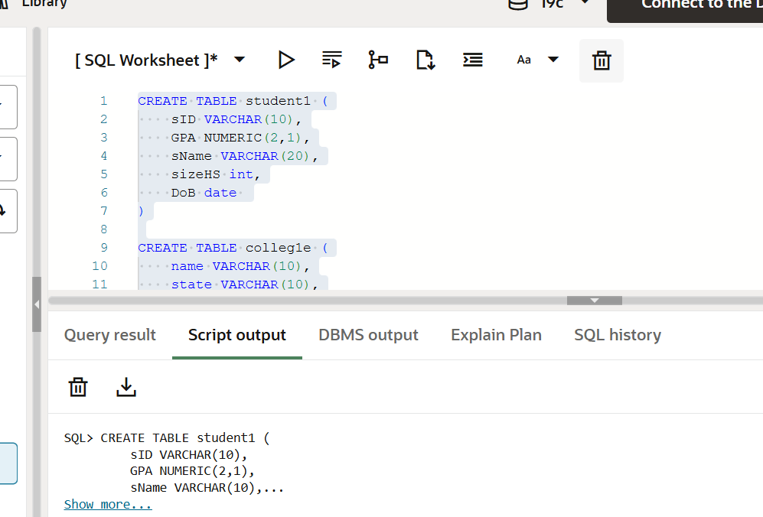
INSERT INTO student1 (SID, sName, GPA, sizeHS, DoB) VALUES (123, 'Amy', 3.9, 1000, TO_DATE('26-JUN-1996','DD-MON-YYYY'));
INSERT INTO student1 (SID, sName, GPA, sizeHS, DoB) VALUES (234, 'Bob', 3.6, 1500, TO_DATE('07-APR-1995','DD-MON-YYYY'));
INSERT INTO student1 (SID, sName, GPA, sizeHS, DoB) VALUES (345, 'Craig', 3.5, 500, TO_DATE('04-FEB-1995','DD-MON-YYYY'));
INSERT INTO student1 (SID, sName, GPA, sizeHS, DoB) VALUES (456, 'Doris', 3.9, 1000, TO_DATE('24-JUL-1997','DD-MON-YYYY'));
INSERT INTO student1 (SID, sName, GPA, sizeHS, DoB) VALUES (567, 'Edward',2.9, 2000, TO_DATE('21-DEC-1996','DD-MON-YYYY'));
INSERT INTO student1 (SID, sName, GPA, sizeHS, DoB) VALUES (678, 'Fay', 3.8, 200, TO_DATE('27-AUG-1996','DD-MON-YYYY'));
INSERT INTO student1 (SID, sName, GPA, sizeHS, DoB) VALUES (789, 'Gary', 3.4, 800, TO_DATE('08-OCT-1996','DD-MON-YYYY'));
INSERT INTO student1 (SID, sName, GPA, sizeHS, DoB) VALUES (987, 'Helen', 3.7, 800, TO_DATE('27-MAR-1997','DD-MON-YYYY'));
INSERT INTO student1 (SID, sName, GPA, sizeHS, DoB) VALUES (876, 'Irene', 3.9, 400, TO_DATE('07-MAR-1996','DD-MON-YYYY'));
INSERT INTO student1 (SID, sName, GPA, sizeHS, DoB) VALUES (765, 'Jay', 2.9, 1500, TO_DATE('08-AUG-1998','DD-MON-YYYY'));
INSERT INTO student1 (SID, sName, GPA, sizeHS, DoB) VALUES (654, 'Amy', 3.9, 1000, TO_DATE('26-MAY-1996','DD-MON-YYYY'));
INSERT INTO student1 (SID, sName, GPA, sizeHS, DoB) VALUES (543, 'Craig', 3.4, 2000, TO_DATE('27-AUG-1998','DD-MON-YYYY'));

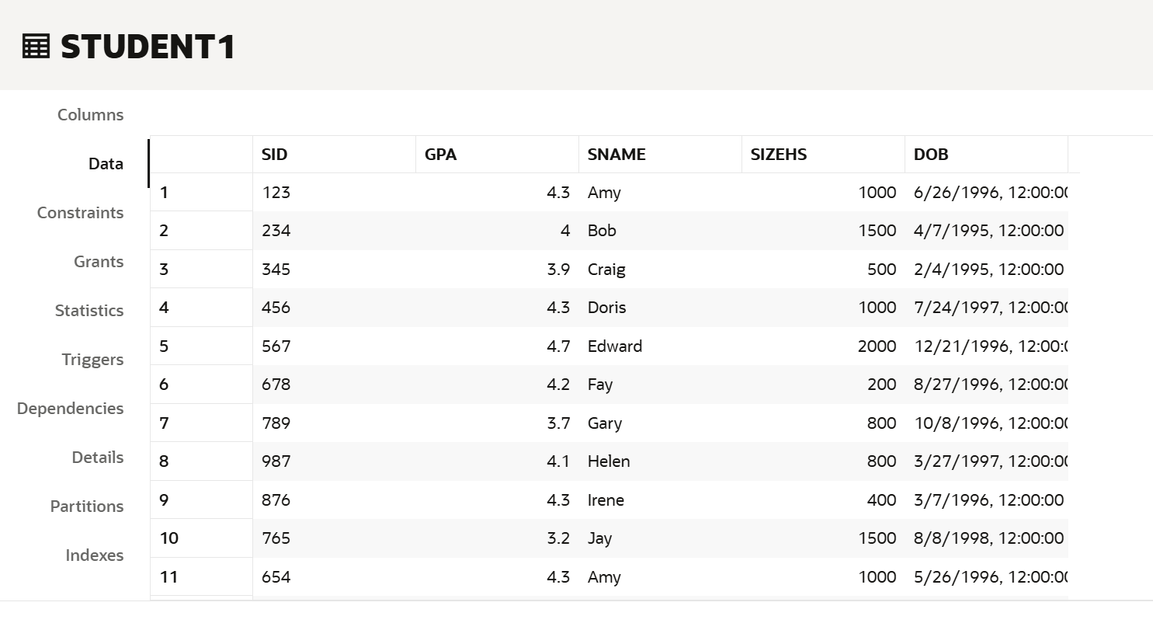
INSERT INTO apply1 (sID, cName, major, decision) VALUES (123, 'Stanford', 'CS', 'Y');
INSERT INTO apply1 (sID, cName, major, decision) VALUES (123, 'Stanford', 'EE', 'N');
INSERT INTO apply1 (sID, cName, major, decision) VALUES (123, 'Berkeley', 'CS', 'Y');
INSERT INTO apply1 (sID, cName, major, decision) VALUES (123, 'Cornell', 'EE', 'Y');
INSERT INTO apply1 (sID, cName, major, decision) VALUES (234, 'Berkeley', 'biology', 'N');
INSERT INTO apply1 (sID, cName, major, decision) VALUES (345, 'MIT', 'bioengineering', 'Y');
INSERT INTO apply1 (sID, cName, major, decision) VALUES (345, 'Cornell', 'bioengineering', 'N');
INSERT INTO apply1 (sID, cName, major, decision) VALUES (345, 'Cornell', 'CS', 'Y');
INSERT INTO apply1 (sID, cName, major, decision) VALUES (345, 'Cornell', 'EE', 'N');
INSERT INTO apply1 (sID, cName, major, decision) VALUES (678, 'Stanford', 'history', 'Y');
INSERT INTO apply1 (sID, cName, major, decision) VALUES (987, 'Stanford', 'CS', 'Y');
INSERT INTO apply1 (sID, cName, major, decision) VALUES (987, 'Berkeley', 'CS', 'Y');
INSERT INTO apply1 (sID, cName, major, decision) VALUES (876, 'Stanford', 'CS', 'N');
INSERT INTO apply1 (sID, cName, major, decision) VALUES (876, 'MIT', 'biology', 'Y');
INSERT INTO apply1 (sID, cName, major, decision) VALUES (876, 'MIT', 'marine biology', 'N');
INSERT INTO apply1 (sID, cName, major, decision) VALUES (765, 'Stanford', 'history', 'Y');
INSERT INTO apply1 (sID, cName, major, decision) VALUES (765, 'Cornell', 'history', 'N');
INSERT INTO apply1 (sID, cName, major, decision) VALUES (765, 'Cornell', 'psychology', 'Y');
INSERT INTO apply1 (sID, cName, major, decision) VALUES (543, 'MIT', 'CS', 'N');
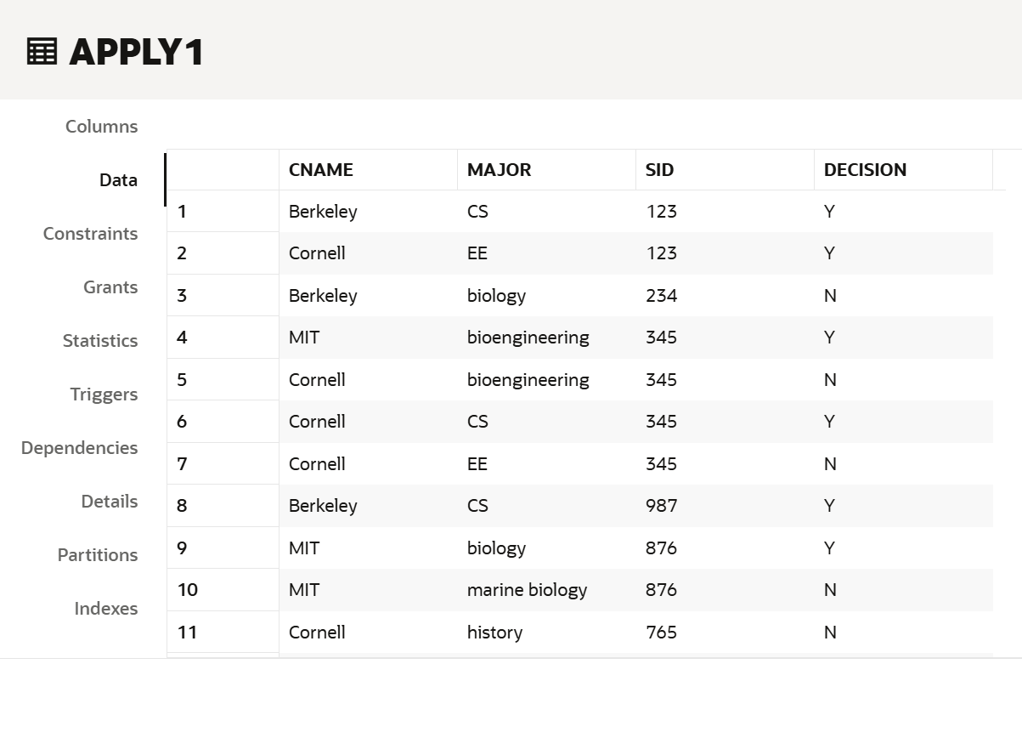
INSERT INTO college1e (cName, state, enrollment) VALUES ('Stanford', 'CA', 15000);
INSERT INTO colleg1e (Name, state, enrollment) VALUES ('Berkeley', 'CA', 36000);
INSERT INTO colleg1e (Name, state, enrollment) VALUES ('MIT', 'MA', 10000);
INSERT INTO colleg1e (Name, state, enrollment) VALUES ('Cornell', 'NY', 21000);
INSERT INTO colleg1e (Name, state, enrollment) VALUES ('Harvard', 'MA', 50040);
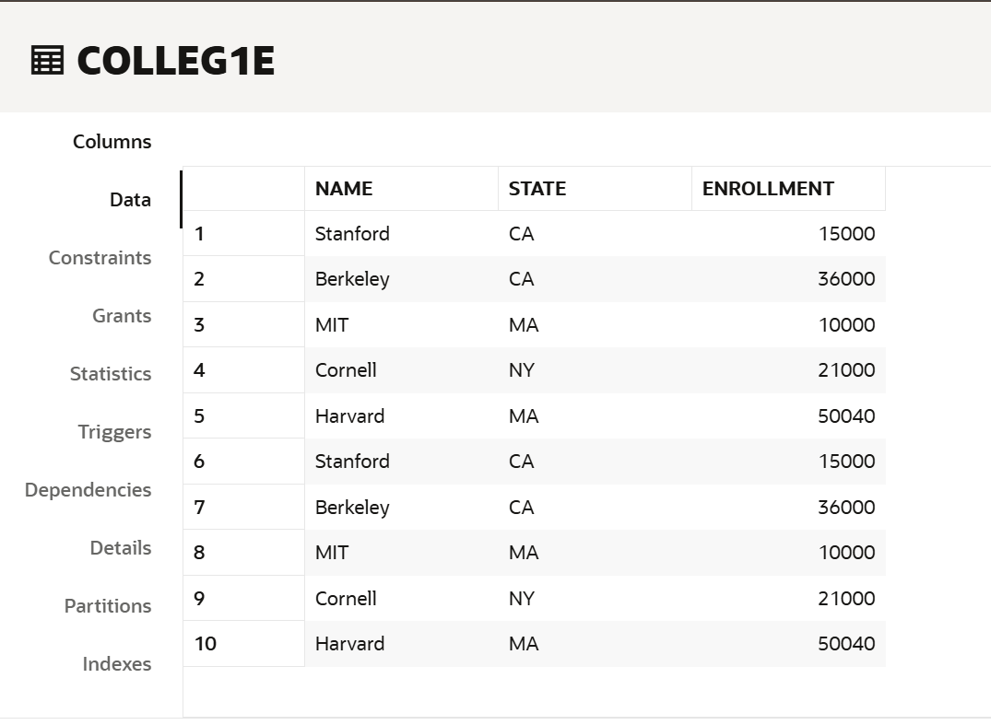

select sname , DoB from student1;
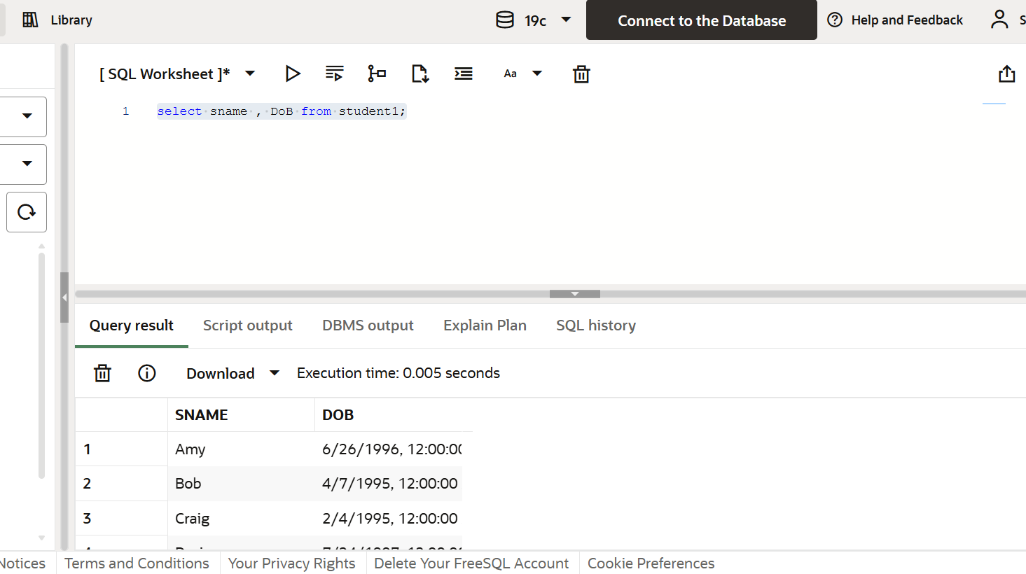

select sname from student1 where gpa >3.7;
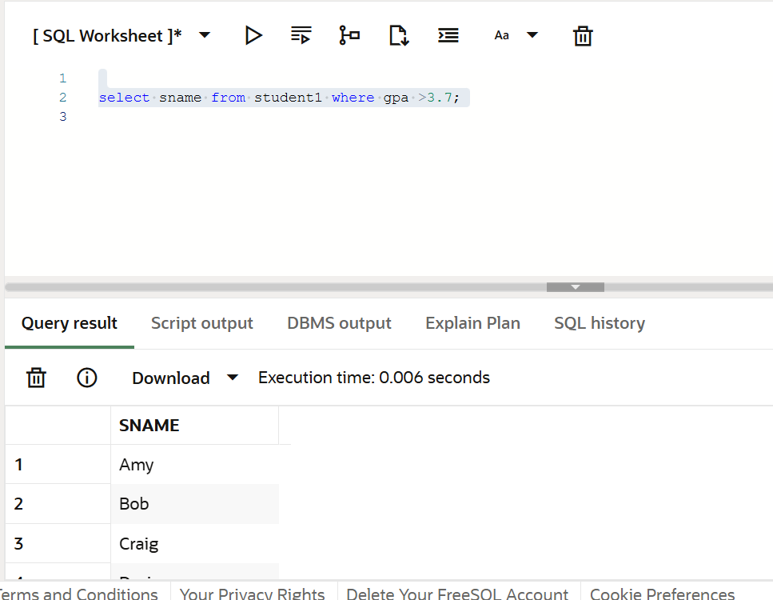

select sname from student1 where sizehs <=100 and DoB>'31-sec-96';
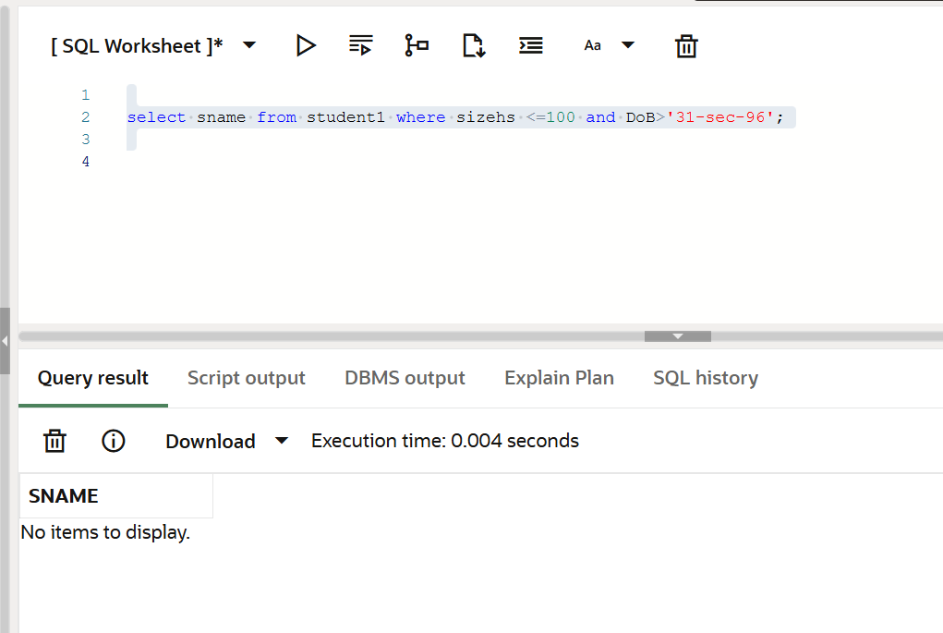

select name from colleg1e where state='NA';
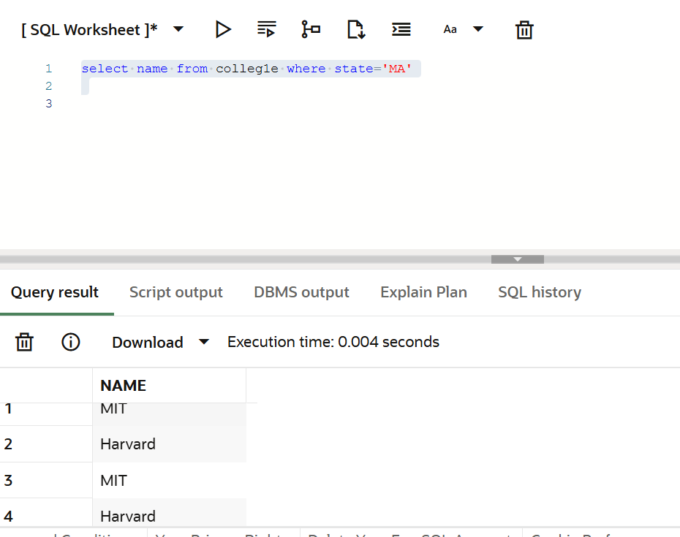

select sname,DoB from student1 where DoB >'1-jul-96' order by DoB asc;
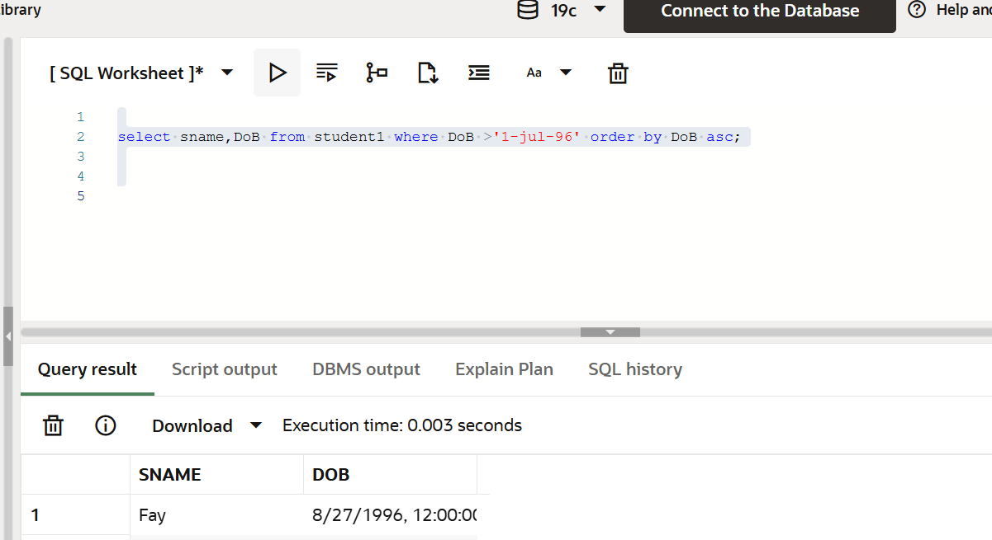

select sid ,cname from apply1 where decision='Y';
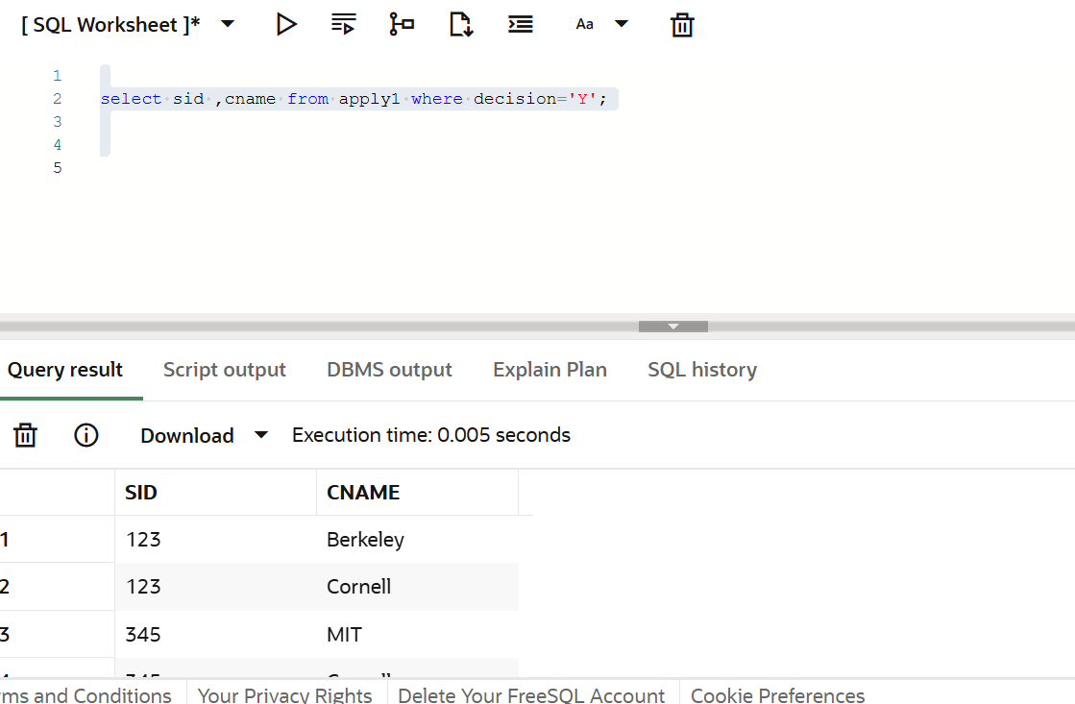

select sid ,cname from apply1 where decision='Stanford';
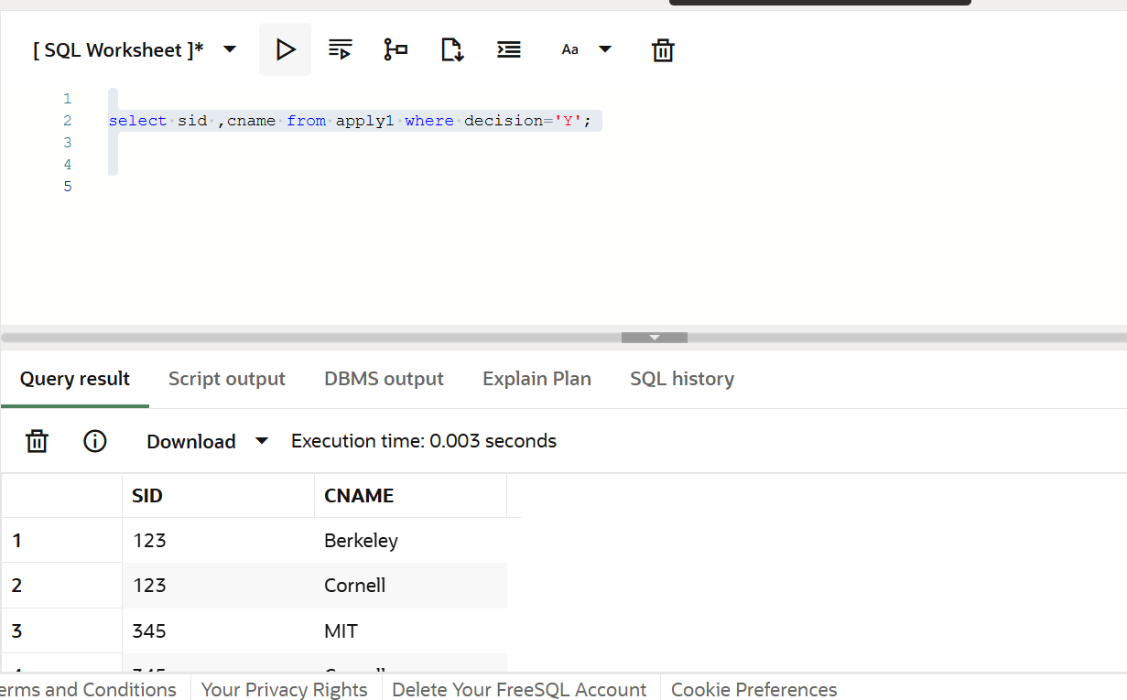

select name from colleg1e where enrollment>10001;
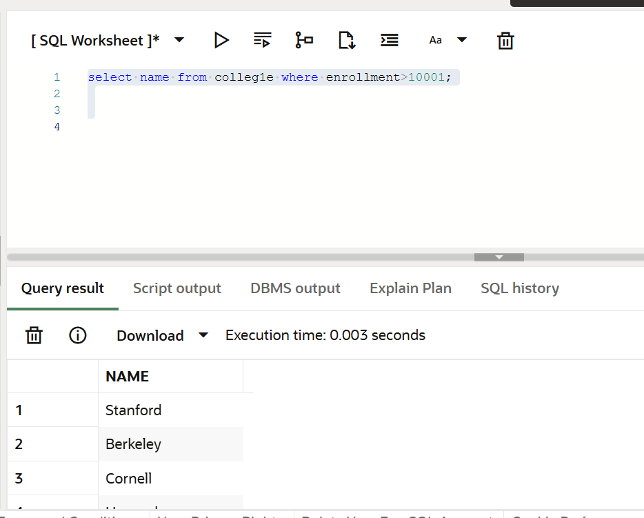

select name from colleg1e where state!='CA';
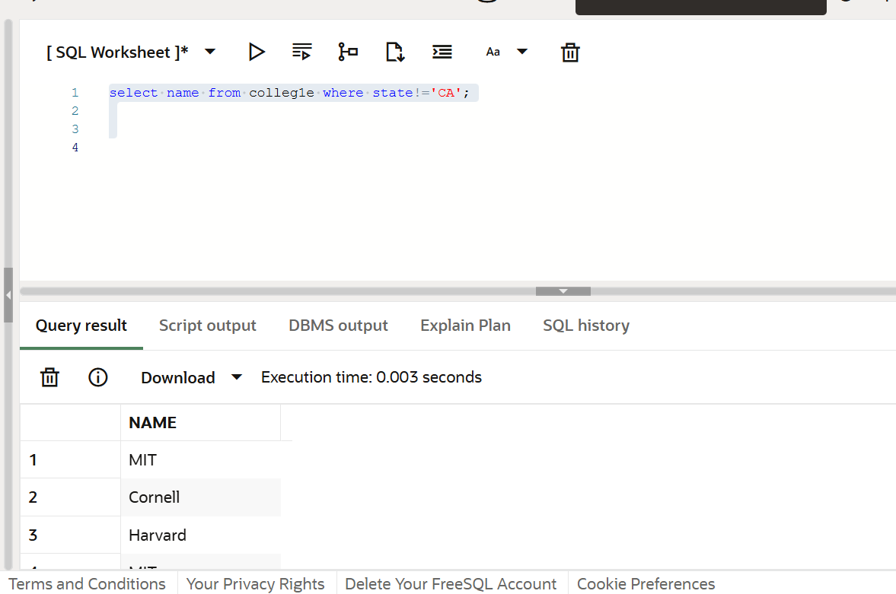

select name from colleg1e where enrollment>10001;
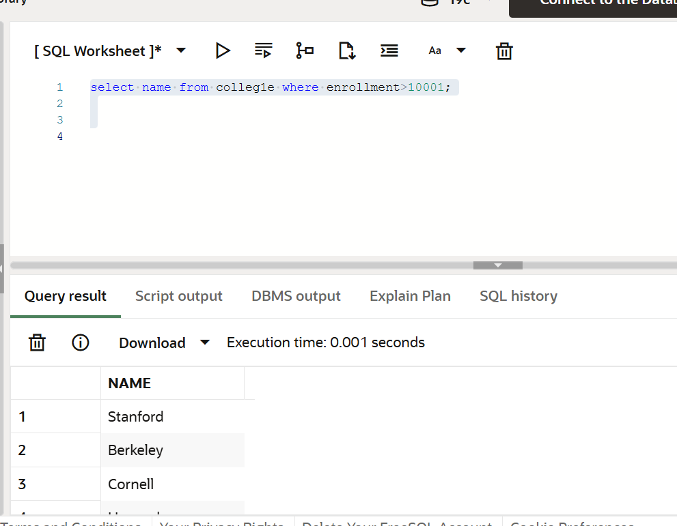

SELECT sName FROM student1 WHERE sizeHS > 17000 AND GPA < 3.8;
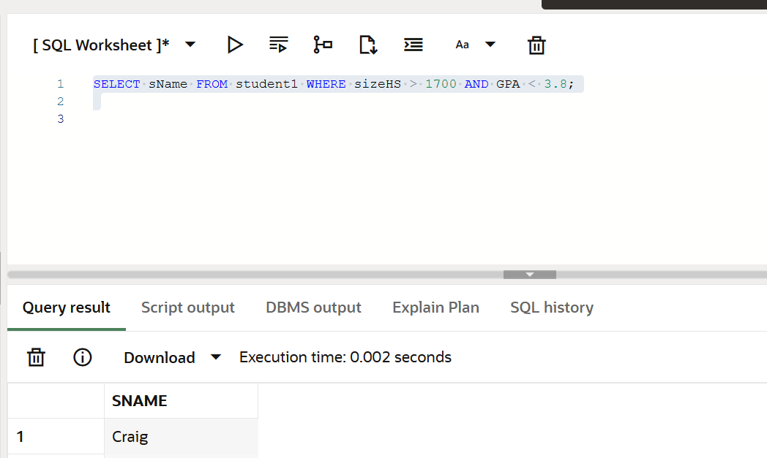
DESC student1;
SELECT * FROM student1; =already shown
SELECT DISTINCT major FROM apply1;
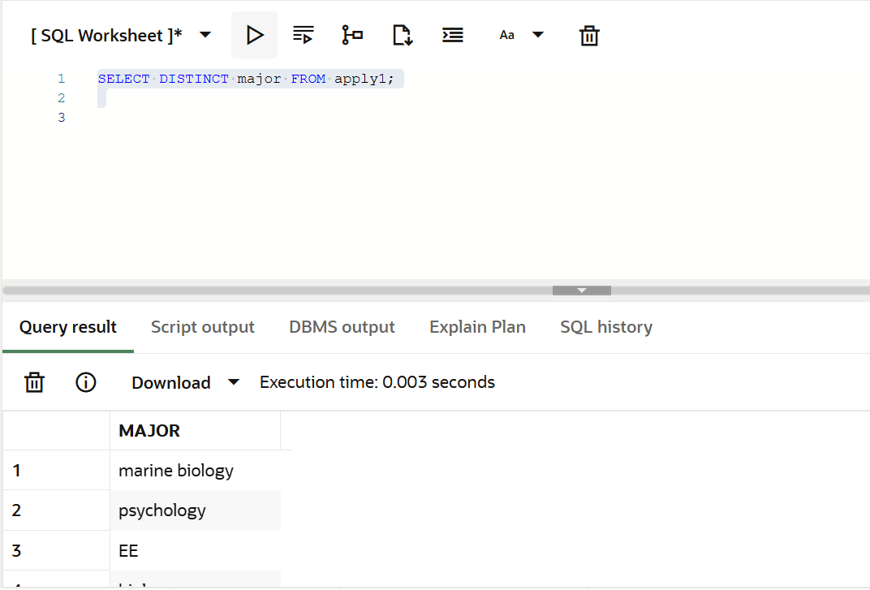

SELECT sName FROM student1 WHERE LENGTH(sName) = 3;
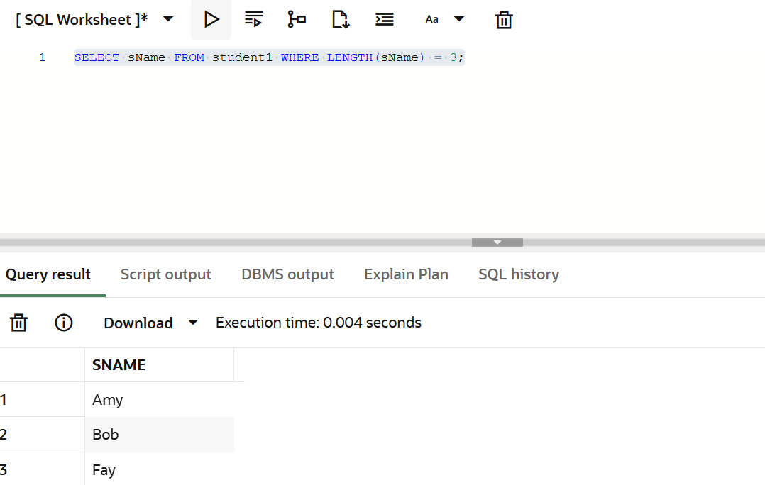

SELECT sName FROM student1 WHERE sName LIKE 'H____';
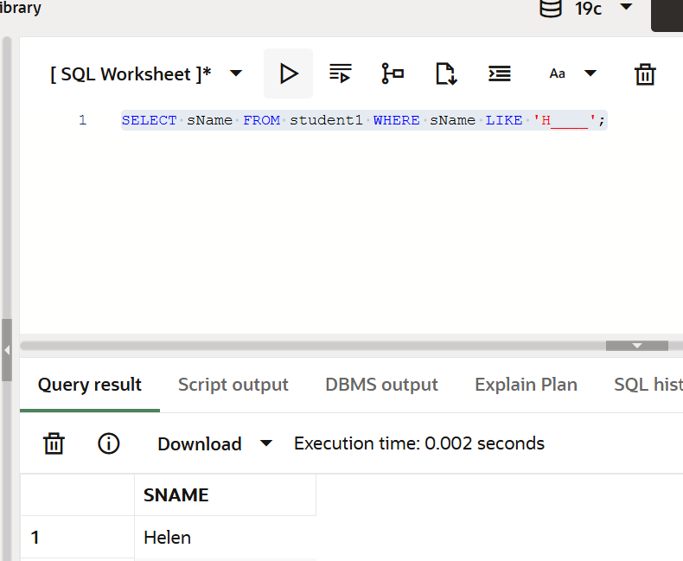
SELECT sName FROM student1 WHERE sName LIKE '%y';
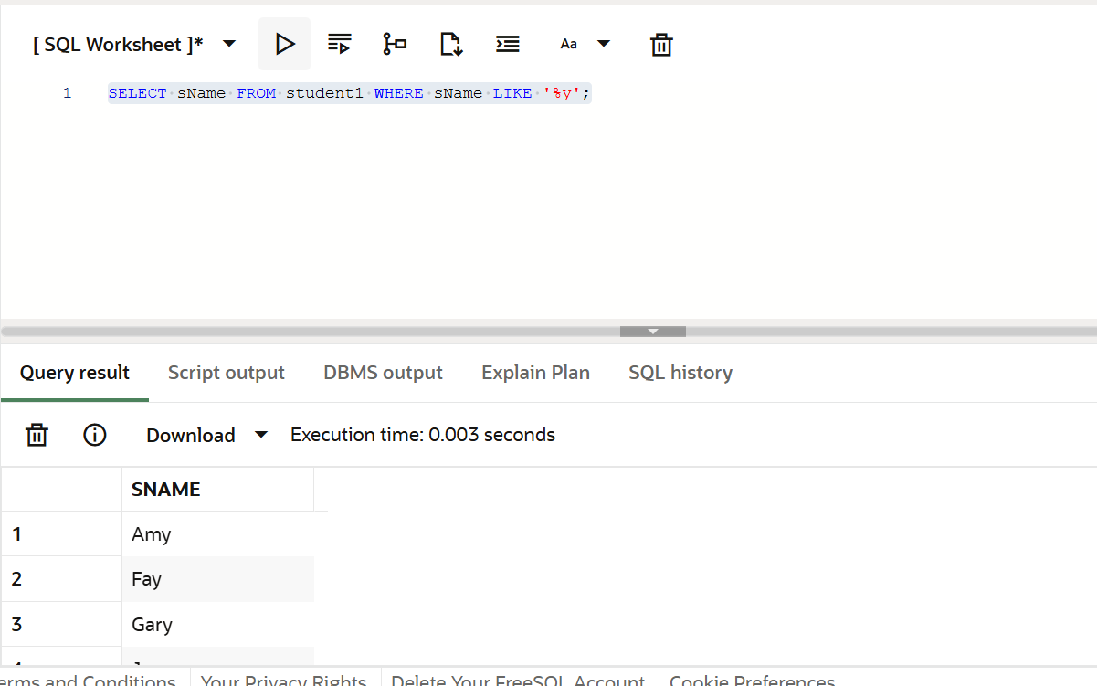

SELECT *FROM student1 ORDER BY GPA;
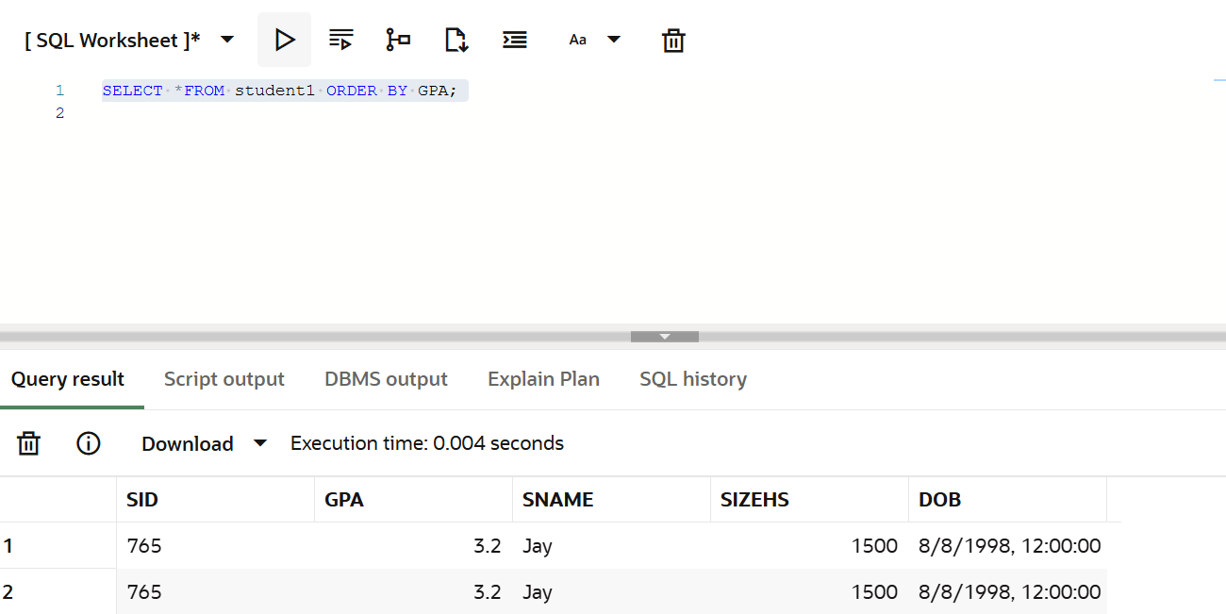

SELECT *FROM student1 ORDER BY GPA ASC, DoB DESC;
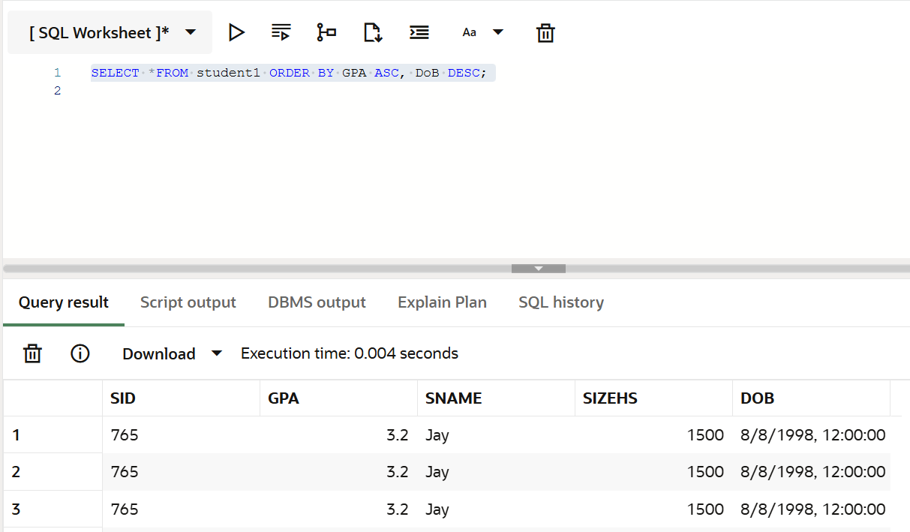

SELECT DISTINCT sID FROM apply1 WHERE cName IN ('Stanford', 'Cornell', 'MIT');
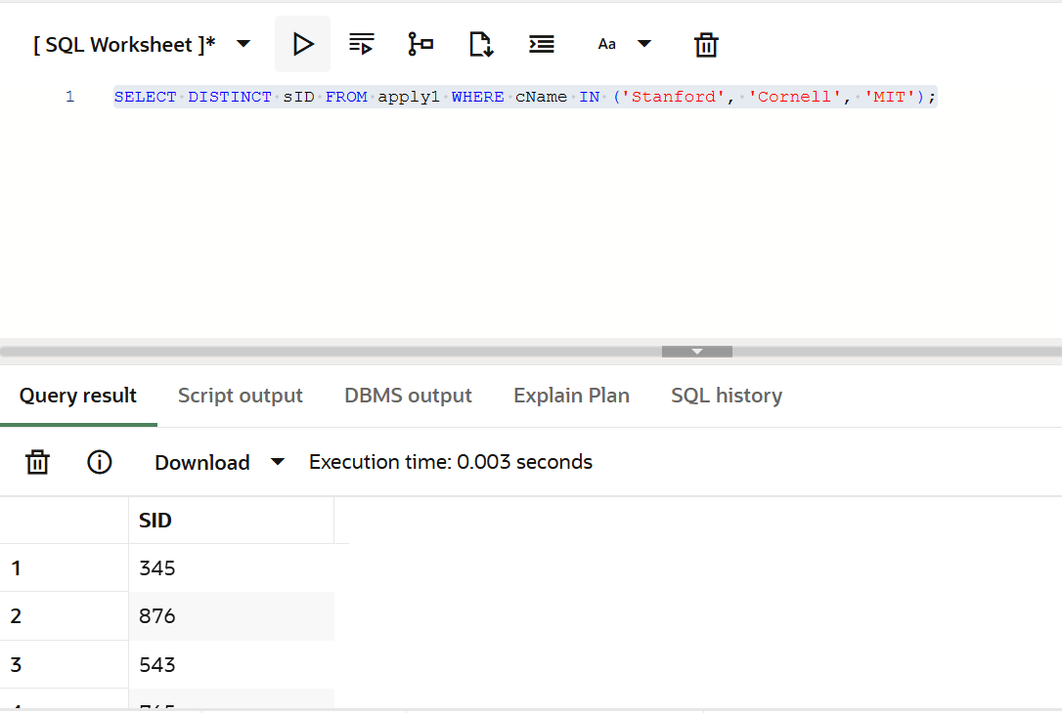

DELETE FROM apply1 WHERE cName = 'Stanford';
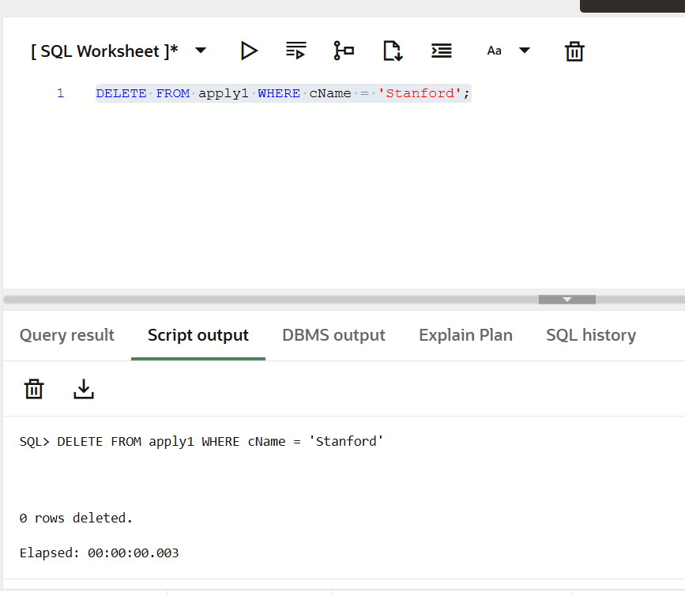

UPDATE student1 SET GPA = GPA + (GPA * 0.10);
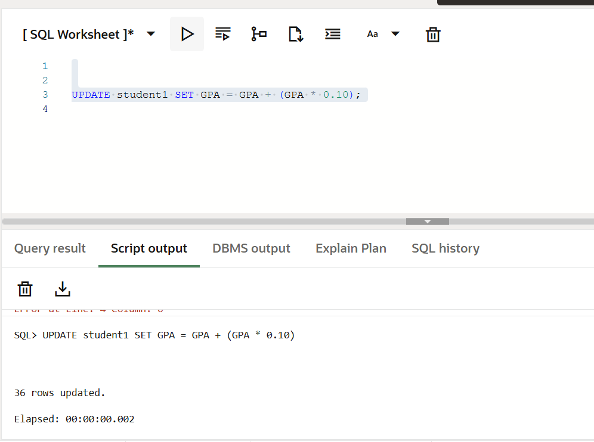

UPDATE student1
SET GPA = GPA + 1.5 WHERE GPA < 3.5 AND sizeHS > 1500;
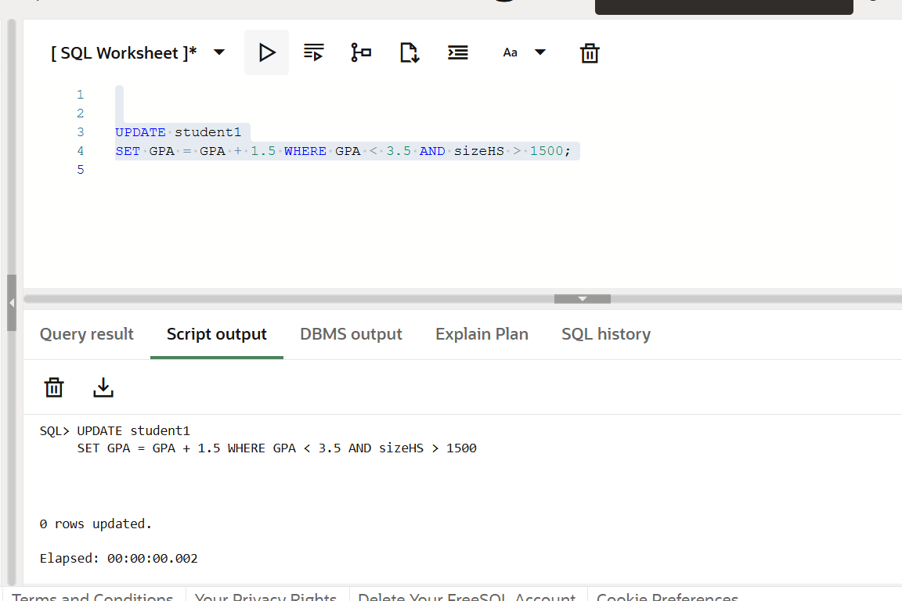

DELETE FROM student1 WHERE GPA < 3.2;
